Dear Sir or Madame
COMPETITION TIME!
Care in Style has an exciting new competition for you!
We truly believe in putting the service users at the heart of the company. So much so, we are offering one lucky person the opportunity to name our brand new respite unit which will be opening in spring 2015 in Westborough Road, Westcliff-on-Sea.
If you are successful you will win 2 tickets for a day trip of your choosing below:
* Chessington world of adventure * London Zoo
* London Dungeons * Madame Tussauds
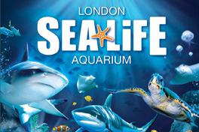
* London Sealife Centre * London Eye + River Cruise

Be Creative and have fun. Please fill in the form below and send it to the address provided. Closing date is the 31st January 2015.
To find out more about Care in Style visit our website www.careinstyle.org
GOOD LUCK!
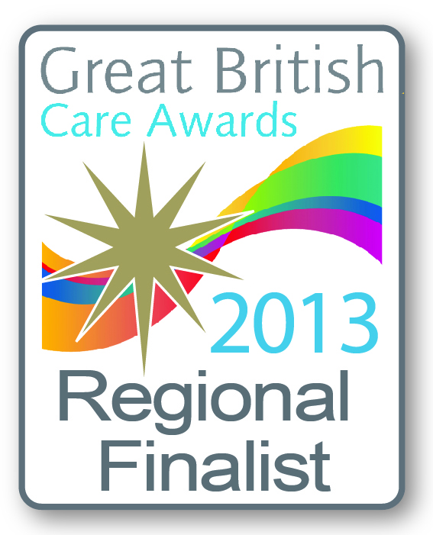
Sam Snell
(Senior Care Co-ordinator)
ssnell@careinstyle.org
www.careinstyle.org

Name........................................................... Phone number..................................................
What do you think the new Respite Unit should be
called?.........................................................................................................................................
Send to: Sam Snell, Care in Style, 403-405 Westborough Road, Westcliff-on-Sea, Essex SS0 9TW

